Public procurement is a critical component of governance and economic development in India. It involves the acquisition of goods, services, and works by public authorities, which is essential for delivering public services and implementing government policies. In India, public procurement accounts for a significant portion of the GDP and plays a vital role in promoting transparency, efficiency, and accountability in government operations.
The market for such opportunities is estimated to be worth INR 50,000 Cr, and therefore it is vital to channelize efforts towards capitalizing on this market and enhancing the market participation of WLEs. As a strategic initiative this can solve for two ever evolving issues arising for the government; first, quality and credibility of vendors on boarded for services, second – promoting livelihoods for women. By bridging the demand and supply gap through the involvement of women led enterprises a transformational change in market scenario can be seen in the coming years.
Current Status of Public Procurement in India
Legal Framework
The legal framework governing public procurement in India is primarily guided by the General Financial Rules (GFR) 2017, which set the guidelines for procurement by various government departments. Additionally, the Public Procurement Bill, 2012 is under discussion, aimed at streamlining procurement processes, ensuring transparency, and fostering competition.
E-Governance Initiatives
The Government of India has made significant strides in digitizing the procurement process through various e-governance initiatives. The following key platforms facilitate public procurement:
Government e-Marketplace (GeM):
Website: gem.gov.in
Launched in 2017, GeM provides a one-stop platform for the procurement of goods and services by government departments, offering transparency and efficiency.
Central Public Procurement Portal (CPPP):
Website: eprocure.gov.in
The CPPP serves as a gateway to various public procurement opportunities across central and state governments, enabling online submission of bids.
State Government Portals:
Each state has its procurement portals (e.g., Maharashtra: mahatenders.gov.in), which cater to local procurement needs.
National E-Governance Division (NeGD):
Website: negd.gov.in
NeGD supports the implementation of e-procurement initiatives across states.
Procurement Statistics
According to the Ministry of Finance, public procurement in India is estimated to be around 30% of GDP. In recent years, procurement through GeM has increased significantly:
As of 2023, GeM has registered over 2 million products and facilitated transactions worth over ₹1 trillion.
Challenges in Public Procurement
Despite the advancements in public procurement in India, several challenges persist:
1. Lack of Transparency
Many procurement processes still lack transparency, leading to corruption and inefficiency. A study by the Transparency International reported that public procurement is one of the most corrupt sectors in India.
2. Capacity Constraints
Government agencies often lack the necessary skills and training to manage procurement effectively. The World Bank highlights that inadequate training leads to poor decision-making and inefficiencies in procurement.
3. Complex Regulations
The existing procurement regulations can be cumbersome, resulting in delays and increased costs. Stakeholders often struggle to navigate the complex legal landscape, leading to non-compliance and disputes.
4. Limited Participation
Smaller vendors and startups face barriers to entry in public procurement due to stringent qualification criteria and a lack of awareness about available opportunities. This limits competition and innovation.
5. Inefficient Processes
Many public procurement processes are still manual and bureaucratic, leading to delays and increased transaction costs. According to a report by the NITI Aayog, inefficient procurement practices can lead to substantial cost overruns.
Mitigation Strategies
To address the challenges in public procurement, the following mitigation strategies can be considered:
1. Enhancing Transparency
Implementation of e-Procurement Systems: Expanding the use of platforms like GeM and CPPP to ensure that all procurement processes are conducted online, thereby reducing the scope for corruption.
Regular Audits and Reporting: Establishing mechanisms for regular audits of procurement processes and mandatory reporting of procurement data to promote accountability.
2. Capacity Building
Training Programs: Developing comprehensive training programs for government officials involved in procurement to enhance their skills and knowledge.
Partnerships with Educational Institutions: Collaborating with universities and training institutes to provide specialized courses on public procurement management.
3. Simplifying Regulations
Reviewing and Streamlining Regulations: Conducting a thorough review of existing procurement regulations to identify and eliminate redundant processes, making it easier for agencies to comply.
Creating Standardized Procurement Templates: Developing standardized templates for procurement documents to reduce complexity and enhance efficiency.
4. Promoting Inclusivity
Awareness Campaigns: Conducting awareness campaigns to educate small businesses and startups about public procurement opportunities and the bidding process.
Simplifying Eligibility Criteria: Revising eligibility criteria to lower barriers for smaller vendors, ensuring a more diverse range of suppliers can participate.
5. Digitizing Processes
Investing in Technology: Investing in advanced technologies such as AI and blockchain to enhance procurement processes and ensure data security and transparency.
Feedback Mechanisms: Establishing mechanisms for feedback from vendors to continuously improve the procurement process based on their experiences.
Involving Women-Led Enterprises in Public Procurement
Encouraging the participation of women-led enterprises in public procurement is essential for promoting gender equality and economic empowerment. The following strategies can help achieve this goal:
1. Awareness and Capacity Building
Targeted Awareness Campaigns: Conduct campaigns specifically aimed at women entrepreneurs to inform them about public procurement processes and opportunities available through platforms like GeM and CPPP.
Training Programs: Develop training modules focused on building the necessary skills for women entrepreneurs in areas such as bid preparation, project management, and compliance with procurement regulations.
2. Simplifying Procurement Processes
Tailored Eligibility Criteria: Adjust eligibility criteria in tender documents to make them more accessible for women-led enterprises. This could involve relaxing requirements for prior experience or turnover thresholds.
Dedicated Quotas: Introduce quotas or set-asides in public procurement for women-led enterprises to ensure their participation in tenders.
3. Financial Support and Incentives
Financial Assistance Programs: Create government-backed loan schemes and grants to support women entrepreneurs looking to enter public procurement.
Incentives for Government Departments: Provide incentives for government departments that successfully engage with women-led businesses in their procurement processes.
4. Building Networks and Partnerships
Support Networks: Establish networks for women entrepreneurs to connect with each other and share best practices related to public procurement.
Collaborations with NGOs: Partner with non-governmental organizations and women’s associations to reach a broader audience of women entrepreneurs and facilitate their entry into public procurement.
5. Monitoring and Reporting
Data Collection: Implement mechanisms to collect and analyze data on the participation of women-led enterprises in public procurement. This data can inform policy adjustments and track progress over time.
Regular Reporting: Require government departments to report on their procurement activities concerning women-led enterprises, fostering accountability and encouraging best practices.

Public procurement in India is a vital aspect of governance that significantly influences the economy. While significant progress has been made in digitizing and streamlining procurement processes, challenges such as lack of transparency, capacity constraints, and complex regulations persist. By implementing targeted mitigation strategies, the government can enhance the efficiency, transparency, and inclusivity of public procurement, ultimately contributing to better governance and economic development.

SC ST hub Public Procurement
The Government of India envisions entrepreneurship as an integral part of accomplishing rapid and robust economic growth. To ensure, that benefits of growth spread across all sections of the society, especially the marginalized groups including SC/ST entrepreneurs, Government is trying to make procurement activities of the public sector more inclusive and participative.
In this regard, the “Public Procurement Policy for MSEs” mandates that Central Government Ministries, Departments, and Public-Sector Undertakings procure a minimum of 25% of their total annual value of goods or services from Micro and Small Enterprises including 4% of total procurement of goods and services from Micro and Small Enterprises owned by SC & ST entrepreneurs and 3% of total procurement of goods and services from Micro and Small Enterprises owned by women entrepreneurs.
Therefore, in an endeavor to mainstream SC/ST groups into the entrepreneurial ecosystem, a number of schemes have been launched by the Ministry of MSME. Additionally, the Hon’ble Prime Minister also launched Start-Up India initiative, facilitating bank loans aimed at promoting entrepreneurship at the grass root level enabling economic empowerment and subsequent job creation. To expedite achievement of the policy target, the Government has established the National SC/ST Hub with an aim not only to increase market access and ensure higher participation of SC/ST entrepreneurs in public procurement but also to promote the creation of new enterprises. Ministry of Micro, Small and Medium Enterprises, Government of India has made an initial allocation of Rs. 490 Crore for the period 2016-2020 for the National SC/ST Hub.
NITI AAYOG Report
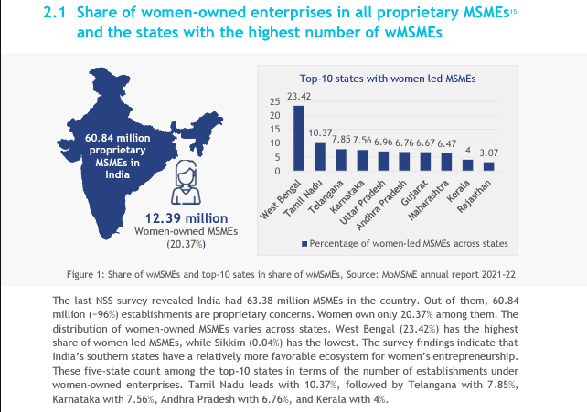
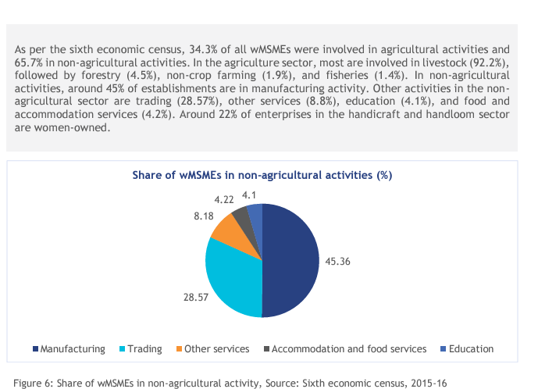
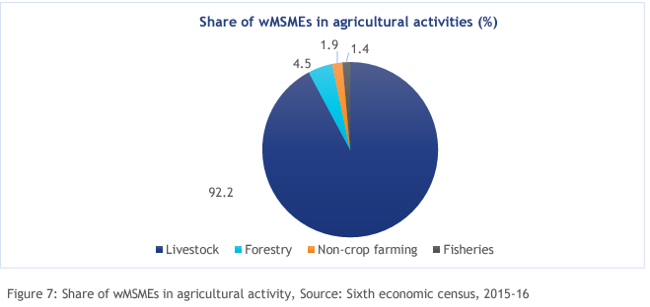
International models of PP enabling women led enterprises.
Definition of gender-responsive public procurement (GRPP)
GRPP is procurement that promotes gender equality through the goods, services or works being purchased. This means that buyers and suppliers examine the impact of all contracted activities on women’s and men’s needs, interests and concerns, and design and deliver contracts in a way that reduces inequalities. It does not necessarily entail higher costs, but does require knowledge and capacity.
Recently, the Government of India has moved one step ahead to set a milestone for SMEs. As mandated by the government of India, every Central Ministry /Department / PSUs shall set an annual target for 25% procurement from MSE. Moreover, a sub-target of 4% out of 25% target of annual procurement earmarked for procurement from MSEs owned by SC/ST entrepreneurs.
Special provision for Micro and Small Enterprise owned by women. Out of the total annual procurement from Micro and Small Enterprises, 3% from within the 25% target shall be earmarked for procurement from Micro and Small Enterprises owned by women.

References
- Government of India. (2023). Ministry of Finance.
- Transparency International. (2022). Corruption in Public Procurement.
- World Bank. (2021). Procurement Capacity Assessment.
- NITI Aayog. (2022). Report on Procurement Practices in India.
- Government e-Marketplace. (2023). GeM Statistics.
- Central Public Procurement Portal. (2023). CPPP Overview.

